Open Space &
Play Area Strategy


2014 – 2033

Area Profile: Holcombe Rogus

Report produced on behalf of Mid Devon District Council by Ethos Environmental Planning | 

HOLCOMBE ROGUS AREA PROFILE

1.0 Introduction

1.1 Holcombe Rogus

Holcombe Rogus is a village in Mid Devon situated near the Devon-Somerset border in a rural location quite close to the Blackdown Hills and north-east of Tiverton. The population of the parish is 521 inhabitants. The village is famous for the manor house known as Holcombe Court, which was built by the Bluett family and is described as "perhaps the finest Tudor house in Devon". Holcombe Rogus does not suffer from significant or widespread social deprivation according to the English Indices of Multiple Deprivation (2010).

1.2 Natural Environment and Green Space Provision

The area benefits considerably from the Grand Western Canal running between Tiverton and Greenham, where it terminates. The Canal is a regional walking and cycling route, popular with a wide range of recreational users. Parts of the canal are also designated as a Local Nature Reserve and County Wildlife Site. Holcombe Court is on the local register of historic parks and gardens and also includes areas of ancient woodland, County Wildlife Site, SSSI and trees protected by Tree Preservation Orders.

According to the Green Infrastructure Assessment (GIA, 2013), which groups Holcombe Rogus in a catchment area with Burlescombe and Hockworthy, strategic accessible open space and accessible woodland are very limited and the average green infrastructure per head of the population is a little below average for the district.

1.3 Housing and Development

The Local Plan review proposes to designate Holcombe Rogus as a village suitable for limited development, due to the level of services and facilities available. In the previous Local Plan the village was not designated in this way so very little housing has been built in recent years. The Strategic Housing Land Availability Assessment (SHLAA, 2013) did not identify any potential housing sites.

2.0 Map of Parish and Open Space Provision

Figure 1: Provision of open space across the parish
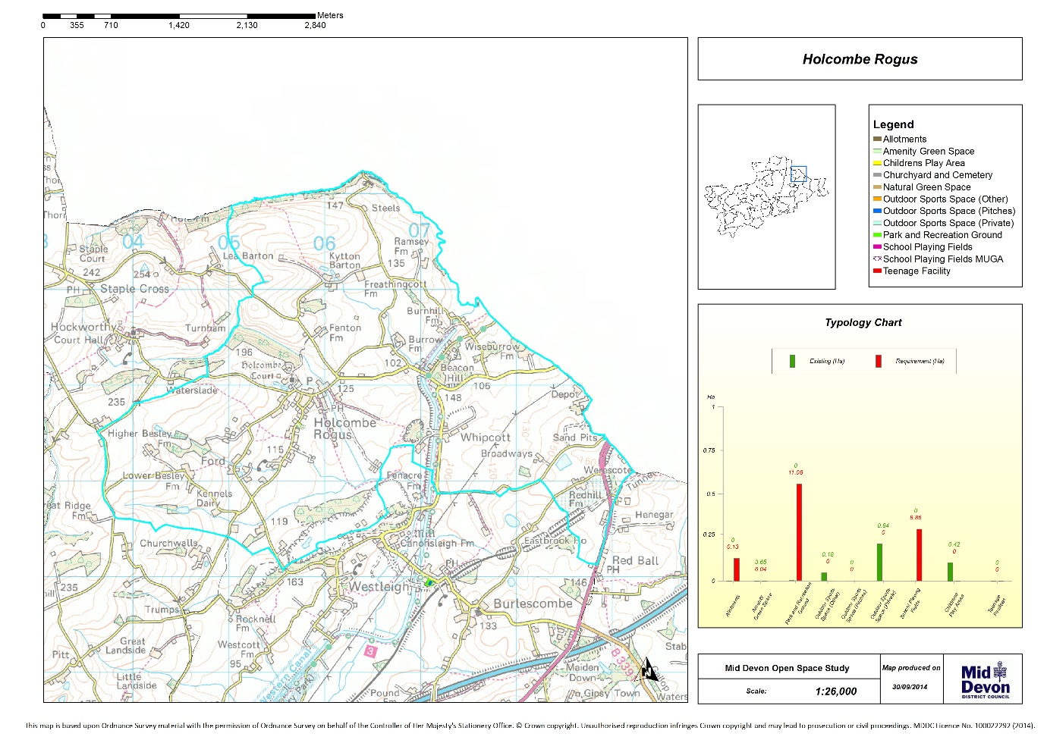

3.0 Quantity Analysis

Table 1 shows the quantity analysis of open space for the area. The figures for ‘Park and Recreation Ground (combined)’ comprise the sum of the following typologies:

- Park and Recreation Ground;
- Outdoor Sports Space (Pitches);
- Outdoor Sports Space (Other);
- Outdoor Sports Space (Private).

It is the ‘combined’ figure that is used for the purpose of analysing quantity, as such it is only this figure where required provision and supply is relevant. Figures have been provided for the individual typologies which make up the combined figure for information only, however, there is no supply assessment for these, hence an ‘NA’ (Not Applicable) is provided.

Existing quantity figures are also provided for a number of typologies where there are no standards, as such these also do not show figures for required provision (a figure of 0.00 is provided) and supply is ‘NA’, these typologies are:

- School Playing Fields;
- School Playing Fields MUGA;
- Churchyard and Cemetery.

Table 1: Quantity analysis of open space in the Parish
Typology | Number of sites | Existing provision (hectares) | Existing provision (ha/1000) | Required provision (ha) | Required provision (ha/1000) | Supply (ha) | Supply (Ha/1000) | Supply
Allotments | 0.00 | 0.00 | 0.00 | 0.13 | 0.25 | -0.13 | -0.25 | UNDER SUPPLY
Amenity Green Space | 1.00 | 0.31 | 0.60 | 0.52 | 1.00 | -0.21 | -0.40 | UNDER SUPPLY
Park and Recreation Ground (combined) | 0.00 | 0.00 | 0.00 | 0.78 | 1.50 | -0.78 | -1.50 | UNDER SUPPLY
Park and Recreation Ground | 0.00 | 0.00 | 0.00 | 0.78 | 1.50 | -0.78 | -1.50 | N/A
Outdoor Sports Space (Other) | 0.00 | 0.00 | 0.00 | 0.00 | 0.00 | 0.00 | 0.00 | N/A
Outdoor Sports Space (Pitches) | 0.00 | 0.00 | 0.00 | 0.00 | 0.00 | 0.00 | 0.00 | N/A
Outdoor Sports Space (Private) | 0.00 | 0.00 | 0.00 | 0.00 | 0.00 | 0.00 | 0.00 | N/A
Children’s Play Area | 1.00 | 0.04 | 0.08 | 0.03 | 0.06 | 0.01 | 0.02 | SUFFICIENT SUPPLY
Teenage Facility | 0.00 | 0.00 | 0.00 | 0.01 | 0.02 | -0.01 | -0.02 | UNDER SUPPLY
School Playing Fields | 0.00 | 0.00 | 0.00 | 0.00 | 0.00 | 0.00 | 0.00 | N/A
School Playing Fields MUGA | 0.00 | 0.00 | 0.00 | 0.00 | 0.00 | 0.00 | 0.00 | N/A
Churchyard and Cemetery | 0.00 | 0.00 | 0.00 | 0.00 | 0.00 | 0.00 | 0.00 | N/A

4.0 Access Analysis

Figure 2: Access to park and recreation grounds across the parish (600m buffer)
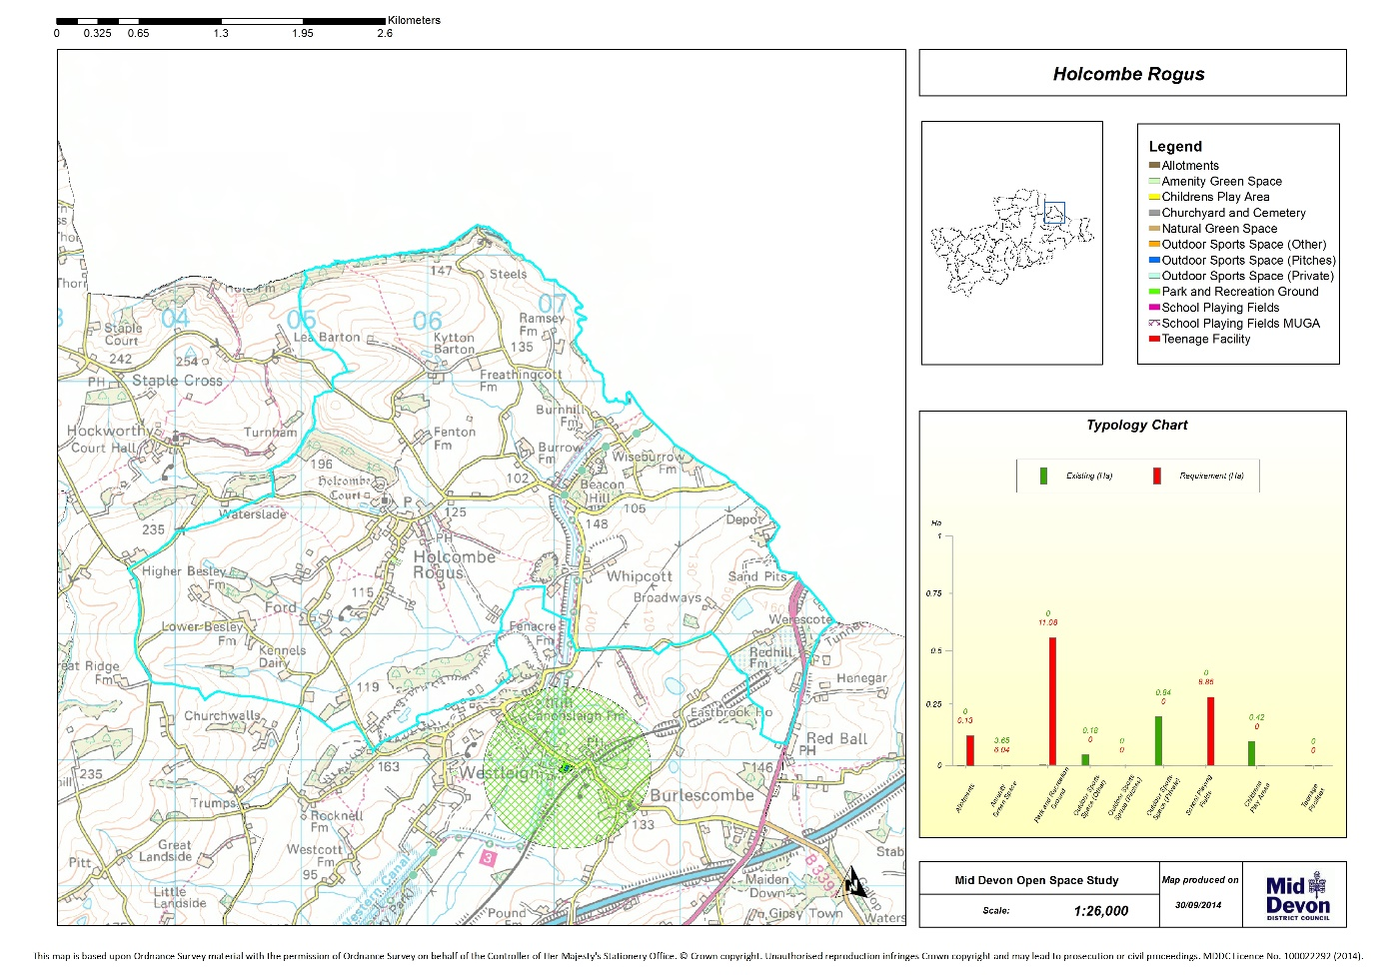

Figure 3: Access to Children’s Play Areas across the parish (300m buffer)
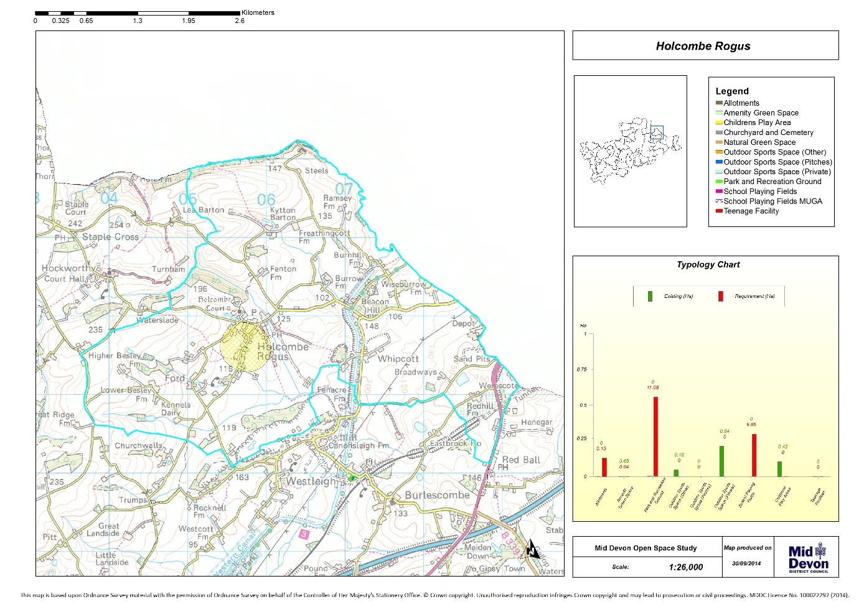

Figure 4: Access to teenage facilities across the parish – no provision
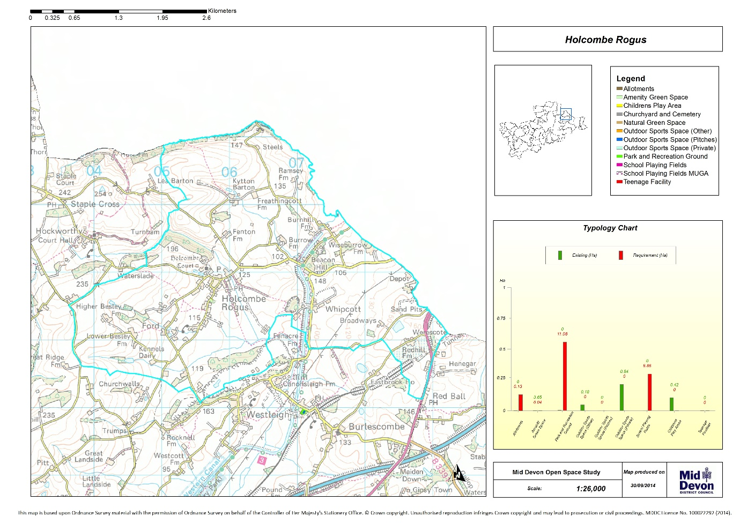
Figure 5: Access to amenity green space across the parish (300m buffer)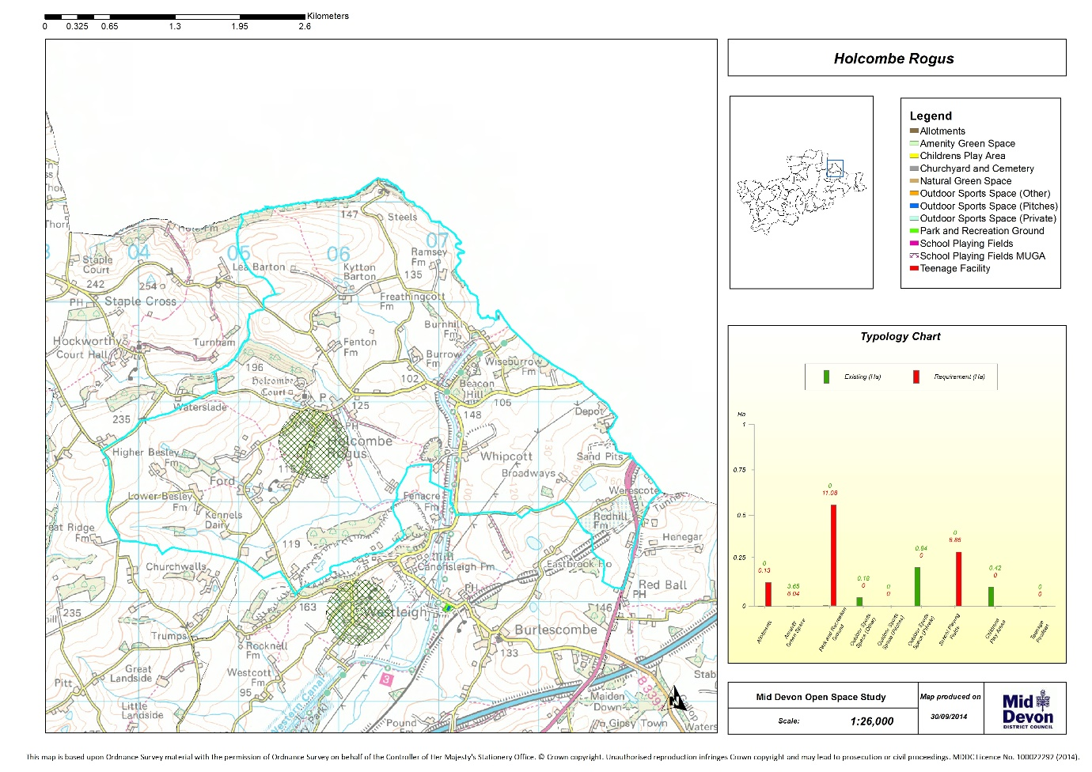

Figure 6: Access to allotments across the parish – no provision

5.0 Quality Analysis

The District Council provides a large playing field within the village of Holecombe Rogus, it has a play area, a kick about area with goal posts and a natural BMX area. The play area provides a good selection of play equipment for a range of children and the field can be used by the whole community. The remaining open spaces are adequate.

6.0 Summary and Priorities

The priority for Holcombe Rogus is the provision of Teen Facilities.

