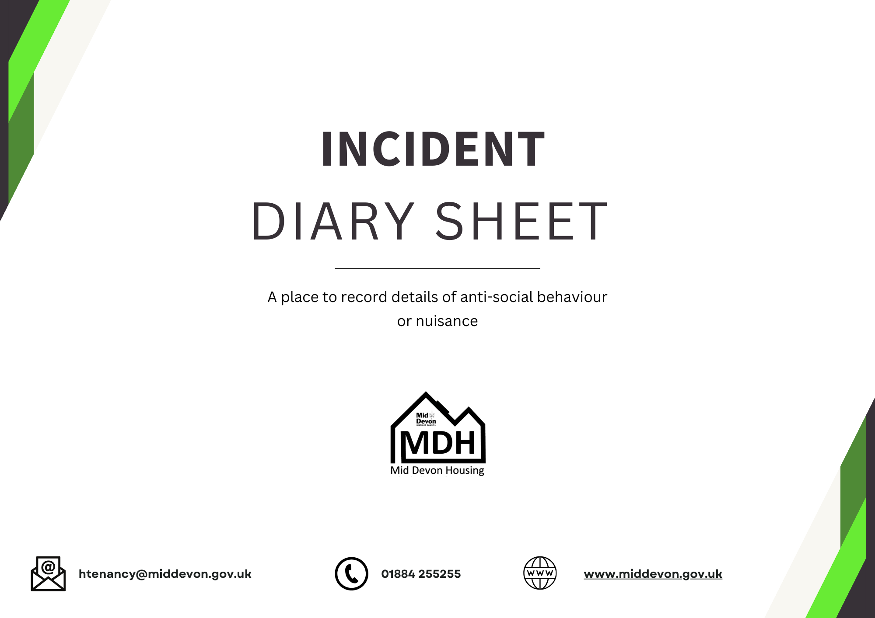



**INITIAL REPORT**

OF NUISANCE

**Date of initial report: _____________________________**

**Report completed by: _____________________________**

*If neither party in this reporting form is a MDH resident we are unable to assist. If this is the case please report to [Mid Devon District Council.](https://www.middevon.gov.uk/your-council/customer-services/contact-details-and-opening-hours)

|  |  |
| --- | --- |
| **Name of Reporting Party** |  |
| **Address of Reporting Party** |  |
| **What is your preferred method of contact?** |  |
| **Contact Details of Reporting Party** |  |

|  |  |
| --- | --- |
| **Who was involved in the incident?**  *(Please give name and address, or a description and any distinguishing features)*  ***\*****If the other party is a minor try to establish approx. age and who parents/guardians are* |  |
| **What type of incident are you reporting?** | ASB/Violence/Noise/Harassment/Domestic Abuse/Hate Crime/Vulnerabilities/Mental Health/Substance Abuse  (delete as necessary) |
| **When did the incident happen including the date and time it took place?** |  |
| **Tell us what happened?**  *Please tell us exactly what you saw or heard* |  |

**Initial** **Report**:

|  |  |
| --- | --- |
| **Have you reported the issue to the Police?**  *\*If yes try and obtain a crime reference number* |  |
| **What have you done to resolve the issue?**  *Have you spoken to the other party about the issue?* |  |
| **Where did the incident take place?** |  |
| **How did the incident effect you?**  *Please tell us the way the incident has made you feel, include its effect on the people you live with, e.g. has it stopped you sleeping? Has it frightened your children?* |  |
| **What we can do to help resolve this issue?** |  |
| **What would be your ideal outcome to resolve the issue?** |  |

Yes

No

**Further Details:**

We would like to make contact with the person/s identified above to make them aware of the reported behaviour and give them an opportunity to comment about incident and where appropriate, give them a chance to change their behaviour.*

I am happy for you to contact the person/s identified as responsible for the incident

I confirm

**I confirm the details I have completed in this form are accurate and true to the best of my knowledge and belief**

I confirm

**Please be aware that where we have a duty to pass information to a statutory agency such as the police or Social Services, such as where a child is at risk, we will be speaking directly to the relevant agency giving full details of the situation.**

*Please tick to confirm you have read and understood this.*

**I am happy for you to discuss my report with other partner agencies \***

*To help us deal effectively with nuisance we work closely with other partner agencies such as the police, local authority and Community Safety Partnership.*

Yes

No

**I am happy for you to disclose my identity to the person/s identified as responsible for the incident \***

*Please be aware, if you choose No, MDH will not reveal your identity to the other party. We will still need to contact you for details of the incident and to record any future incidents. Not disclosing your identity may limit our ability to investigate your report or agree any form of action. While we will not disclose your identity if you do not want us to, we cannot stop people from making assumptions.*

No

Yes

|  |  |
| --- | --- |
| CAS Record raised? | *If no provide detail* |
| Acknowledgement letter sent? | *Provide date sent* |

*For office use only*