

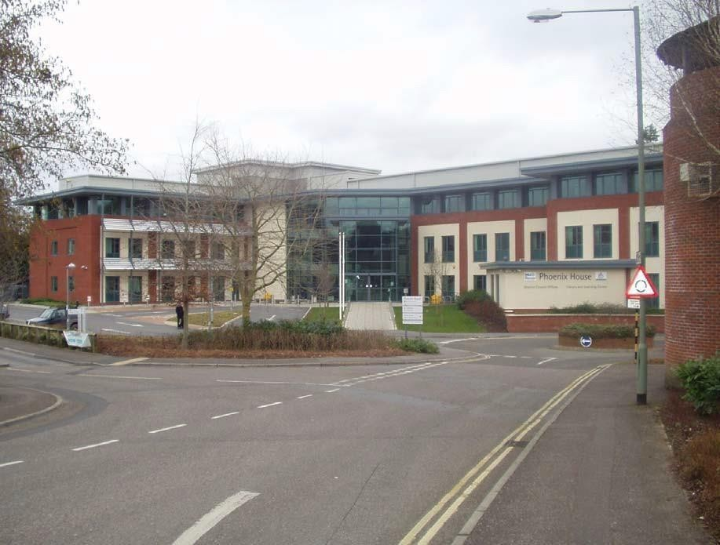

Pre-application advice from the Planning Service at Mid Devon District Council

(Including pre-application & discretionary fees and charges for 2026/27)

Why seek pre-application advice?
Open and constructive discussions are an opportunity for the Local Planning Authority and developers to work together to achieve developments that deliver benefits to the community and the economy. Therefore, we welcome and encourage discussions at an early stage and in advance of the application being received.

Spending time and effort in preparing your scheme is more likely to result in a good quality and acceptable development and also help us process your application quickly. High quality, comprehensive applications also allow the Parish or Town Council and the public to understand what is being proposed and its implications on the locality.

Experience has shown that pre-application advice can save time, costs and frustration and optimise the potential of a site.

How the scheme works and what we need from you.

How the scheme works

The scheme seeks to give you a better understanding of the way a planning application will be considered against the national and local policies and other relevant issues (known as ‘material considerations’). Hence, pre-application advice will give you more certainty as to how your proposal is likely to be received.

Through this understanding, we aim to help you to overcome potential difficulties through suggested amendments and ensure that the information submitted by you in support of your application addresses the relevant planning issues.

You might ask us to comment in writing or request a meeting with one of the Council’s planning officers and consultees such as the Highway Authority or the Environment Agency, where relevant. However, their attendance will in most cases be outside of our control.

Meetings will be held in the Council offices during our normal opening hours, or, if considered more appropriate by your case officer, on site.

Requests for pre-application advice, including a request for a meeting, need to be made either by email to dcregistration@middevon.gov.uk or in writing and sent to:

Development Management, Mid Devon District Council, Phoenix House,
Phoenix Lane, Tiverton, Devon
EX16 6PP

They must also be accompanied by the appropriate fee. The fees are based on the size, type and likely complexity of the proposal. It may include a site visit by the planning officer, administration costs and any research work undertaken prior to meetings.

The fee schedule is found later in this document and sets out the maximum number of meetings that can be provided for that fee. For some proposal types it also provides the opportunity for a bespoke fee to be arranged with us to address your specific needs.

On receipt of a properly made pre-application request, we will implement a timetable for responding to you. You will find these timescales later in this document in the section entitled “What you can expect from us”.

Aside from consultation with main consultees, a pre-application submission will not be subject to any publicity with the public.

There is an expectation that you will respond positively to the advice given when the application is formally submitted.

If you have any queries on how this system works, please contact us on 01884 234262 or email us at dcregistration@middevon.gov.uk

What we need from you

You may find it helpful to obtain advice from an independent planning specialist who has the experience and expertise that can help make sure your application has the best chance of being given permission. To provide comprehensive pre-application advice we will normally need:

- A completed application form available on our website page: Pre-application advice

- A plan showing the site and identifying other land within the ownership or control of the applicant.

- Any relevant planning history that you are aware of such as the existing use, a schedule of any existing floorspace and any known planning restrictions, for example whether the site lies within a Conservation Area or affects a Listed Building. This information is available on the Council’s website or in the Council’s offices.

- A topographical site survey or other information sufficient to understand existing and proposed site levels in relation to the surrounding area. This may include photos.

- A description of the proposal, including a calculation of any additional floorspace if appropriate.

- Any necessary scaled plans, elevations, sections, photographs or sketches. (Photos are often very useful to understand the proposal and its context).

- Your contact details and whether you are requesting a meeting.

- The pre-application advice fee

When we receive a written request for pre-application advice we will check whether sufficient information has been submitted for us to understand the site, its surroundings and the proposed scheme.

We may need further information before offering pre-application advice in writing. Timescale standards for the issuing of written advice will only begin once sufficient information has been received and will only apply to proposals where a fee is charged.

Where appropriate we will consult with external bodies in relation to your pre-application proposal. This will most typically relate to services provided by Devon County Council (DCC) or statutory consultees. Some of these bodies will have their own “charged for” pre-application service, therefore their input would not normally be available within a single pre-application response where only the district council pre-application fee is paid. Any pre-application response will signpost the paid for services offered by relevant consultees.

2026/27 CHARGES

- Fees have increased to reflect inflation in line with MDDC’s wider charges.
- We have revised some fees for smaller scale applications to recognize that historically we charged more for some householder advice than for small minor applications.
- We have revised fees for applications based upon site area with no development scale identified to bring them more in line with dwelling number / m2 floorspace fees for equivalent sized sites.
- We have added new discretionary / enforcement enquiries.
- We have revised hourly rates for Planning Performance Agreements.
- We have added to our monitoring fee costs to reflect the acquisition during 2026/27 of improved S.106 recording software and consequent Licensing costs.
- Explicitly removed proposals from town & parish councils from charging.

VAT

VAT is payable upon discretionary services offered by the district council. Whilst the provision of a pre-application service is an example of good practice, encouraged by the NPPF (See paragraphs 40-43 December 2024 edition) it is not mandatory and therefore comprises a discretionary service.

Advice has been sought by the council relating to the application of VAT to Planning Performance Agreements. (PPA’s) These are considered to represent the sourcing of a resource to undertake the planning appraisal work that is required of the planning authority. On this basis, VAT is not applied to PPA schemes. Similarly, monitoring fees are exclusive of VAT as the activities undertaken in monitoring discharge of planning obligations do not comprise a discretionary activity.

Our Pre-App charges
Details of how to make payment will be supplied on receipt of your request.

Pre-App Fee Description | New Fee  Including VAT
House Holder Desktop (no meeting no site visit) | £316.00
House Holder  One meeting no site visit | £490.00
Listed Building Advice  where the works do not require planning permission (no site visit included) | £316.00
Listed Building  site visit (where agreed) | £490.00
House Holder & Listed Building site visit | £897.00
Additional meeting or site visit (On top of fees set out above) | £150.00
Small Minor
Residential – 1 dwelling Desktop evaluation with one meeting | £552.00
Residential – 1 dwelling Desktop evaluation no meeting | £316.00
Non-residential  Less than 200 sq. m floorspace | £400.00
Change of use with no works | £316.00
Site visit – additional fee | £150.00
Medium Minor
Residential  2 – 4 dwellings | £1,283.00
Non-residential  200 – 499 sq. m floorspace | £1,283.00
Large Minor
Desktop evaluation, one meeting & one written response
Residential  4 – 9 dwellings | £2,456.00
Non-residential  500 – 999 sq. m floorspace | £2,456.00
Site area 0.5 to 0.99 Ha (where no. of dwellings or floorspace is unknown) | £983.00*
Small Scale Major
Desktop evaluation, one meeting & one written response
Residential 10 - 30 dwellings | £4,083.00
Non-residential  1,000 – 4,999 sq. m floorspace | £4,083.00
Site area - 1 – 1.99 Ha (where no. of dwellings or floorspace is unknown) | £1,634.00*
Medium Scale Major
Desktop evaluation, two meetings & two written responses
Residential 31-149 dwellings | £8,139.00
Non-residential  5,000 – 9,999 sq. m floorspace | £8,139.00
Site area of 2 – 3.99 Ha (where no. of dwellings or floorspace is unknown) | £3,255.00*
Large Scale Major
Desktop evaluation up to three meetings and written responses
Residential  more than 150 dwellings | £14,693.00
Non-residential  over 10,000 sq. m floorspace | £14,693.00
Site area more than 4 Ha (where no. of dwellings or floorspace is unknown) | £5,876.00*
Anaerobic Digesters | £4,904.00
Where a fee is accompanied by an * the pre-application request is likely to lack sufficient detail to establish a general scale of development. In such cases the pre-application response will relate to issues of principle rather than possible detail and consultee input will be proportionately less detailed where sourced.
Other
Solar pv | £4,083.00
Wind turbines | £4,083.00
Lawful development certificate | £316.00
Affordable housing scheme 100% | 50% of the relevant pre-application fee | Subject to VAT

Please note all pre-application enquiries only concerning disabled access/requirements and registered charities will be free of charge.

Planning Performance Agreements (PPA)

A PPA is a project management tool which the local planning authorities and applicants can use to agree timescales, actions and resources for handling particular applications. It will cover the pre-application and application stages but may also extend through to the post-application stage. This service is a bespoke service which can provide specialist support and expertise relevant to the proposal. The cost of the service is based on the hourly rates of the officers and experts who provide the service.

Upon receipt of a request to enter into a PPA, (to include but not limited to 1:1250 site location plan, drawings of the proposal, photographs of the site and surroundings, draft Design and Access Statement together with any other relevant attachments) the planning authority will offer an initial inception meeting with the applicant team. This will enable the authority to understand the nature of the project and proposed timeline and be able to present a draft PPA to include likely costs and any fee capping arrangements. This meeting is not charged for.

- Area Team Leader / Area Planning Officer Time - £85 per hour
- Principal Planning Officer Time - £65 per hour
- Other MDDC specialist input £65 per hour

In addition, the planning authority will add a £5 per hour administration fee to the overall cost.

Currently, the planning authority cannot offer the inclusion of DCC services as a part of its PPA, however the PPA can signpost DCC’s and other relevant pre-application offers and introduce DCC to the project timeline and key contacts.

VAT is not charged for PPA’s

Notes –
- Floorspace refers to gross external floorspace.
- The larger element of a mixed use scheme will primarily be used to determine which category of fee applies to the proposal.
- For the purposes of charging, flats and holiday accommodation are considered as houses.
- Residential development includes Class C2, C2a, C3 & C4.
- For gypsy / traveler proposals, each pitch is equivalent to a dwelling
- The meeting cost is a flat rate fee based on a planning officer attending a meeting, not the length of the time the meeting takes.
- Fees will be subject to periodic review, normally annually
- The charge applies to advice received from Mid Devon District Council officers only
- Due to the costs of processing refunds the Planning Service are unable to issue refunds for amounts £5 or less
- Please note, we do not accept cheques.

Planning Obligation monitoring fees.

The planning obligations monitoring fee is a standard charge relating to the administration, monitoring and management of a planning obligation. It is sought as part of the wider negotiation process on Section 106 agreements. The monitoring fee is payable prior to or upon execution of the planning obligation deed, unless alternative arrangements have been agreed. The monitoring fee supports the Council in maintaining S.106 records, liaison with developers and consultees in relation to the submission and approval of schemes and details required by obligations and to fund software support.

Band | Development type / size (Residential) | 2026/27 fee | Notes
A | Villages 1-5 dwellings  Tiverton, Cullompton & Crediton  1-10 dwellings | £1,655.00 | Monitoring fees support the delivery of the planning permission and associated S.106 or stand-alone obligations and are exempt from VAT.  - Where a scheme falling within Bands A-E includes “Discount Market Housing” as part of its affordable housing mix, an additional monitoring fee (currently £400) will be charged for the review of each subsequent sale of a discount market dwelling.  - Where residential schemes also include other elements (for instance commercial uses or BNG), the residential monitoring fee under Bands A–E will be in addition to any relevant Band F (BNG) and/or Band G fees that apply to those additional elements. In all cases, BNG fees (Band F) apply in addition to any other s106 monitoring fees associated with the development.
B | Rural Housing Sites 1-19 dwellings  Tiverton, Cullompton & Crediton 11-19 dwellings | £5,486.00
C | 20-49 dwellings | £8,821.00
D | 50-199 dwellings | £11,757.00
E | 200 or more dwellings | £14,704.00
F | Biodiversity Net Gain (BNG)  (Including Habitat Banks and BNG secured via a Section 106 agreement)  (i) Technical monitoring costs for BNG (ecologist input only) | Ecological monitoring fees will follow Devon County Council’s fee schedule or equivalent ecologist appointment.
F | (ii) Any BNG related trigger requiring action by Mid Devon District Council will be charged at the standard per event monitoring rate | £400 per event
G | All other S.106 agreements not covered by A-F above, each monitoring and administration event for which action is required by a trigger within the S.106 which is not covered by A-F above. The fee relates to each trigger within the agreement. | £400 per event
S.106 Compliance checking |  | Fee including VAT
Initial compliance check fee |  | £210
Each additional obligation |  | £70

Other discretionary planning fees and charges

Fee Description | Fee Including VAT
Enforcement
Confirmation of compliance with an  enforcement case (includes site visit) | £679
Provide copy of Enforcement Notice | £50
Withdrawal of Enforcement Notice to  include checks to ensure that a previously  issued Enforcement Notice has been  complied with, a Compliance Certificate  and withdrawal of the Notice will be  actioned where applicable. | £800
Enforcement query - written response to queries regarding enforcement history on site or confirmation that historic cases have been closed. | £150
Others
Proposals by Town and Parish Councils | No fee
Validation of applications that are incorrect second time around | 25% of Statutory Fee applied for  Plus VAT
Printing of scanned applications | £0.60
Retrieval of microfiche records by planning team (no research undertaken) | £207.00
To provide a planning history and confirm whether there are conditions restricting the use, occupation or permitted development rights. (Advice upon compliance and removal or variation of condition will be a separate pre-application.) | £362.00
To confirm whether trees benefit from TPO / Conservation Area protection where the public do not use the web-based search option. | £207.00

What you can expect from us
Once a request for pre-application advice is received we will dispatch an acknowledgement (either by email or post) within 5 working days stating the name of the planning officer who will handle your enquiry. All communication from you to the Council should be via this officer.

Following consideration of the information received, the case officer will decide whether to bring together a team of Council officers from different disciplines, avoiding the need for you to contact different parts of the Council separately, thus saving you time and giving consistency.
Following the assessment, the case officer may advise you that further information is required, such as financial appraisals, travel plans, transport assessments, and possibly environmental assessments. Should further information be required, the case officer will endeavor to let you know within 12 working days of the enquiry being received. At this stage you will be advised which Council officers it is considered appropriate to bring into the development team.

We will normally contact you to arrange a meeting within 14 working days of receiving a request for a meeting or submission of pre-application proposals when accompanied by the required supporting information.

Following the meeting, the case officer you met will provide a written summary of the issues discussed, and his or her written advice on those issues within 21 working days of the date of the meeting.

Where no meeting is sought, we will issue planning advice in writing within 21 working days of the receipt of the request for advice when accompanied by the required supporting information.

In the case of Environmental Impact Assessment development, we will aim to agree a timescale in advance with you for the issuing of written planning advice. This is in recognition of the complexity of environmental issues and number of consultees that may need to be involved at the pre-application stage. Where a scheme is likely to be subject to environmental assessment then early discussions should focus on issues relating to the screening and scoping of the proposal.

These timescales can be extended by your written agreement.

Our advice

Our advice will clearly lay out the issues which would be raised by the development (in so far as they can be identified at the pre-application stage). Unless a specific request is made, the advice will relate to key planning issues only and not cover every possible planning issue.

Where relevant, our advice will specify what improvements can be made to the scheme to make it acceptable or if the principle of the development is unacceptable, what the grounds for refusal would be likely to be.

We will clearly identify what level of community consultation will be expected in order to meet the requirements of the Council’s Statement of Community Involvement.

Advice will be given on the nature and quality of information required with your planning application including supporting documents. We will list the documents that will be needed.

We will apply the main Development Plan policies that the application will be assessed against together with Supplementary Planning Documents (if relevant to the proposal). Where policies require the proposal to make a financial contribution such as towards public open space or air quality, we will seek to identify this in the advice together with the likely level of that contribution (if known at this stage).

Where the application is in the ‘major’ category we will seek to agree a timescale with you to project manage the application to decision. This may be through a PPA. Advice will be given on the relevant heads of terms that would be included in any Section 106 Agreement as necessary. Please note that legal fees for drawing up a Section 106 Agreement or to check a submitted Section 106 Agreement / Unilateral Undertaking will be charged separately at the application stage.

A written response may be by way of email reply which will aim to provide comprehensive, but focused advice in a bullet point form.

Although pre-application advice is offered on a without prejudice basis, we will endeavour to ensure that it is as reliable as possible. It will be based on the available information and policies at that time, but will not be a guarantee that a subsequent application will result in a particular decision and will not be binding on the Council. Our opinion may change during the formal application process because of views of consultees and other interested parties such as neighbouring residents. The final decision may also be made by Planning Committee, rather than by officers and it is possible that they may reach a different view.

Advice given in relation to planning history of the site, planning constraints or statutory designations does not constitute a formal response under the provisions of the Local Land Charges Act 1975.

Pre-application advice given will be recorded on our database system and linked geographically to sites. It will be used as a guide to considering subsequent applications in the interests of consistency of advice given.

Whether or not you decide to seek pre-application advice does not affect your right to submit a planning application or to appeal to the Planning Inspectorate in the event that your application is refused. However, where an applicant fails to incorporate advice given at the pre- application stage into a formal planning proposal it is likely the application will be refused without any further negotiation.

What if I disagree with the advice received?

We cannot guarantee that you will like the advice you receive. In most cases, it is differences of opinion rather than factual errors that give rise to disagreement and these can only be resolved through the formal planning process. However, if you feel that something has gone wrong, please explain to the officer involved, as they may be able to clarify the situation.

If you are still dissatisfied with the service provided, it is open to you to make a formal complaint. For further information on the complaints procedure, go to our How our complaints procedure works page or contact Customer Services on 01884 255255.

Design review

Design Review is an independent and impartial evaluation process in which a panel of experts on the built environment assess the design of a proposal. The process is designed to improve the quality of buildings and places for the benefit of the public.

The review is conducted by expert practitioners with current experience in design and development, a record of good design in their own projects and the skills to appraise schemes objectively. It offers feedback and observations that will lead to the improvement of schemes, but does not redesign them.

The process of design review gives decision makers the confidence and information to support innovative, high quality designs that meet the needs of their communities and customers, and to resist poorly designed schemes.

Design review offers the greatest benefits for scheme promoters when undertaken at a pre- application stage before proposals are finalised and can provide valuable feedback at this stage. We will work with scheme promoters to identify and agree schemes suitable to be referred for design review.

There are a range of design review panels operating in the south-west including Shaping better places across the South West - Design Review and the South West Design Review Panel

The cost of taking schemes through design review will normally be met by the promoter and is in addition to the Planning Service’s own pre-application advice charge. The cost will be according to the scale of project and number of panel sessions taken up.

The Planning Portal is a further source of planning guidance and information.

