
JOB DESCRIPTION

POST TITLE: Technical Support Team Leader
POST NUMBER: HB66
GRADE: F
RESPONSIBLE TO: Customer Manager
RESPONSIBLE FOR: Supporting and assisting the Customer Manager and Repairs & Disrepair Manager by implementing technical support and Responsive Repairs property programme. To provide day to day supervision and guidance to the technical support team

LIAISON WITH: Colleagues within Housing Services. External contractor’s management and trades people. Residents, Members of the Public, Elected Members, Service Managers, Trade Bodies and Associations

KEY CORPORATE ACCOUNTABILITIES:
- To assist the Customer Manager and Repairs & Disrepair Manager in the implementation of the authority’s responsive repairs works and tenant technical support.

- To assist the Customer Manager and Repairs & Disrepair Manager with the provision of budgets and estimates.

- Represent the Customer Manager and Responsive Repairs Manager in their absence.
KEY SERVICE ACCOUNTABILITIES:
- Lead by example in delivering an excellent customer experience, ensuring that all aspects of the repairs and technical support service are accessible, responsive, and focused on achieving the best possible outcomes for tenants.

- To provide technical advice and guidance to the Technical Support team and on all aspects of these processes.

- To supervise and monitor the performance of the Technical Support team.

- Liaise closely with the Customer Manager, Repairs & Disrepair Manager and other technical staff in the procurement and delivery of technical customer support and responsive repairs property work regarding resources and available funding.

- Ensure that all relevant data is recorded on the appropriate databases.

- To monitor performance of contractors to ensure quality and value for money.

- When necessary, represent the Council/Business Unit on Working Groups and Partnership bodies outside normal office hours if necessary.

- Maintain an up-to-date knowledge of Legislation and Polices and key developments in the Construction and Housing sector, through continual professional development and identify opportunities to implement best practice.

OTHER DUTIES:
To deliver services effectively, a degree of flexibility is needed, and the post holder may be required to perform work not specifically referred to above. Such duties, however, should not normally exceed those expected of an employee at that grade.
HEALTH AND SAFETY:
The Council has a health and safety policy, which outlines its responsibilities as an employer, and the responsibilities of its employees in respect of health and safety. All employees need to be aware of this policy and comply with its content.

RISK MANAGEMENT:
The Council has a Risk Management Strategy, and it is the responsibility of Heads of Service/Senior Managers to comply with the contents including leading the risk management process within their service, identifying and managing significant operational risks.
DATA PROTECTION:
It is the responsibility of the Post holder to ensure that the section’s requirements for compliance with the Data Protection legislation are met.

SAFEGUARDING CHILDREN AND ADULTS AT RISK:
The Council has a Safeguarding Policy, which outlines its responsibilities and the responsibilities of its employees. All employees need to be aware of this Policy and comply with the contents.
When considering the duties of this role as part of the most recent Job Evaluation (JE), a decision was reached using the government DBS Tool that this role is required to hold a Basic DBS level check. The basis on which this form of DBS is renewed is explained further within our DBS policy.

MID DEVON DISTRICT COUNCIL’S REQUIRED COMPETENCIES

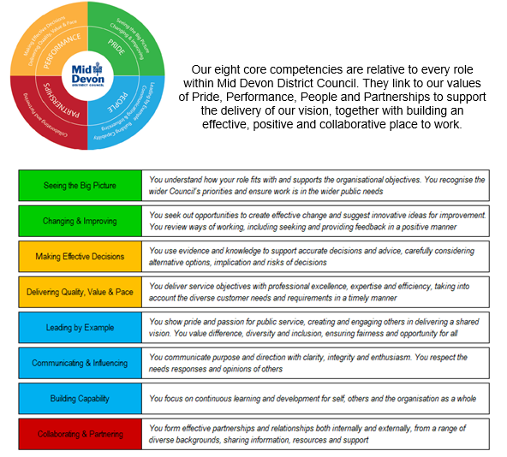

The above competencies should be read in conjunction with the listed policies below. Managerial roles should pay special attention to the expectations of managers as set out within the staff charter.

The Code of Conduct, The Dignity at Work Policy, The Nolan Principles and The Staff Charter

PERSON SPECIFICATION

Customer Team Leader

 | ESSENTIAL | DESIRABLE
Qualifications and Experience: | - Experience of working in a customer focused environment  - Previous supervision and performance management experience  - The ability to lead a team to achieve desired outcomes  - Business Administration Qualification  - Demonstratable experience of performance managing staff | - Diploma in Management Studies or working towards.  - Transparent trail of experience in the housing industry  - Experience of Rethinking Construction/Best Value Partnerships, working in Public Sector Building maintenance  - Environmental monitoring knowledge
Knowledge and Expertise: | - Proven knowledge and understanding of Housing Maintenance and/or experience of property and or construction in the Social Housing sector  - Proven knowledge of Awaab’s law and the obligations around this.  - Understanding of the ‘Decent Homes Standard’  - Proven knowledge and understanding of ‘Tenant Satisfaction Measures’ | - Equality & Diversity assessments  - Knowledge of Housing Management software  .
Skills: | - Excellent written and oral communication skills, such as report writing  - Able to plan or prioritise effectively  - Able to use a wide range of computer software including Excel and Word  - Understanding of Housing Environmental & Energy management related issues
Personal Attributes: | - Committed to equality of opportunity and understanding of diversity issues  - Shows determination to reach targets and objectives  - Able to organise resources to achieve goals  - Demonstrates commitment to Customer Services in all activities  - Communicates regularly and openly and able to handle pressure  - Resilient and able to work to conflicting deadlines  - Self-Motivated  - Positive attitude to change Responsive and supportive to the team and colleagues  - Diplomatic and confidential | - Actively consults and listens to others  - Networks and builds effective working relationships
Special Requirements: | - Understands and is committed to organisational and service improvement.  - Demonstrates drive and determination  - Flexible approach to the requirements of the job  - Full Driving Licence and the ability to attend site visits. | - Seeks ways to continuously improve and learn.
Date: February 2026

