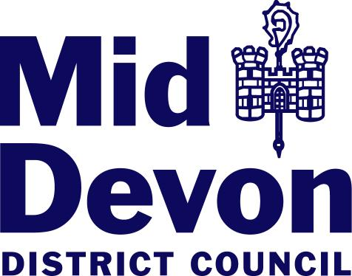
Planning Reference (if known):

Declaration of Generative Artificial Intelligence (AI) Use
Where generative AI has been used to create, assist with or materially alter any part of a planning submission, applicants or agents should declare this at the point of submission.

This form may be used to make that declaration. Alternatively, the same information may be provided within a Planning Statement, Design and Access Statement, covering letter or other appropriate supporting document under a clearly identifiable heading such as “Artificial Intelligence Declaration”.
Further information regarding this requirement is available as part of the Planning Authority’s validation requirements.

Use of Generative AI

Has Generative AI been used to create, assist with or materially alter any part of the submission? | Yes | No
If No, please sign and date the Declaration below.

If Yes, please complete the sections below.

Details of AI Use

Supporting Documents, for e.g. Planning Statement, Design and Access Statement, Technical Reports | Yes | No
Plans and Drawings

Images, photographs or visualisations

Data, analysis or evidence

Other Material

Please briefly describe how AI was used. For example: drafting, editing, summarising, analysing information, generating or altering images, or assisting with conclusions:

Please identify the document(s), image(s), plan(s) or other material affected.

Where AI has been used to generate or materially influence factual information, evidence, analysis or conclusions, please confirm how this material has been checked or independently verified.

Where images or visual material have been generated or altered, please briefly identify what has been changed, added, enhanced or removed.

Declaration
I confirm that “generative” AI HAS / HAS NOT* been used as part of the above referenced application submitted.

Where generative AI has been used, I confirm that the information provided above accurately describes the nature and extent of its use.

I confirm that any factual information, evidence, analysis or conclusions produced or assisted by generative AI have been appropriately reviewed and, where necessary, verified against relevant source material.

I confirm that I, and/or the relevant competent professional responsible for the submitted material, remain responsible for the accuracy, reliability and conclusions of the information submitted.

I confirm that the use of generative AI in the preparation of this planning application has been responsible and lawful.
Name:
Date:
Position: (Applicant/Agent)

Signature:

* Please delete as applicable

